**Group A**

**Lab Assignment 1d**

**Pig Commands**

**29.** load the test data into bag A using **Pigstorage** and show lineage using **ILLUSTRATE**

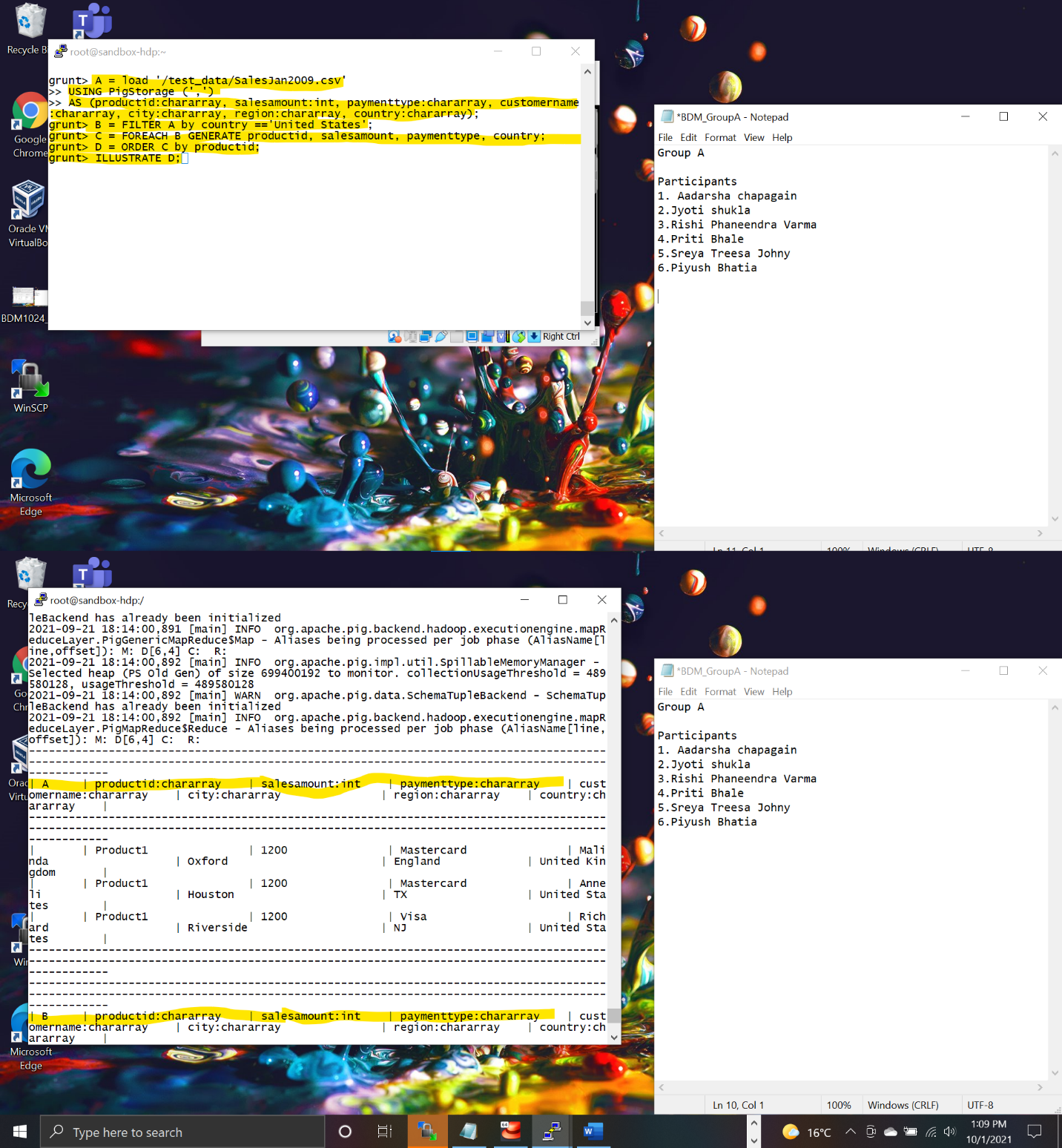

**30.**Dump D to show content of D which is infact content of C ordered by productid

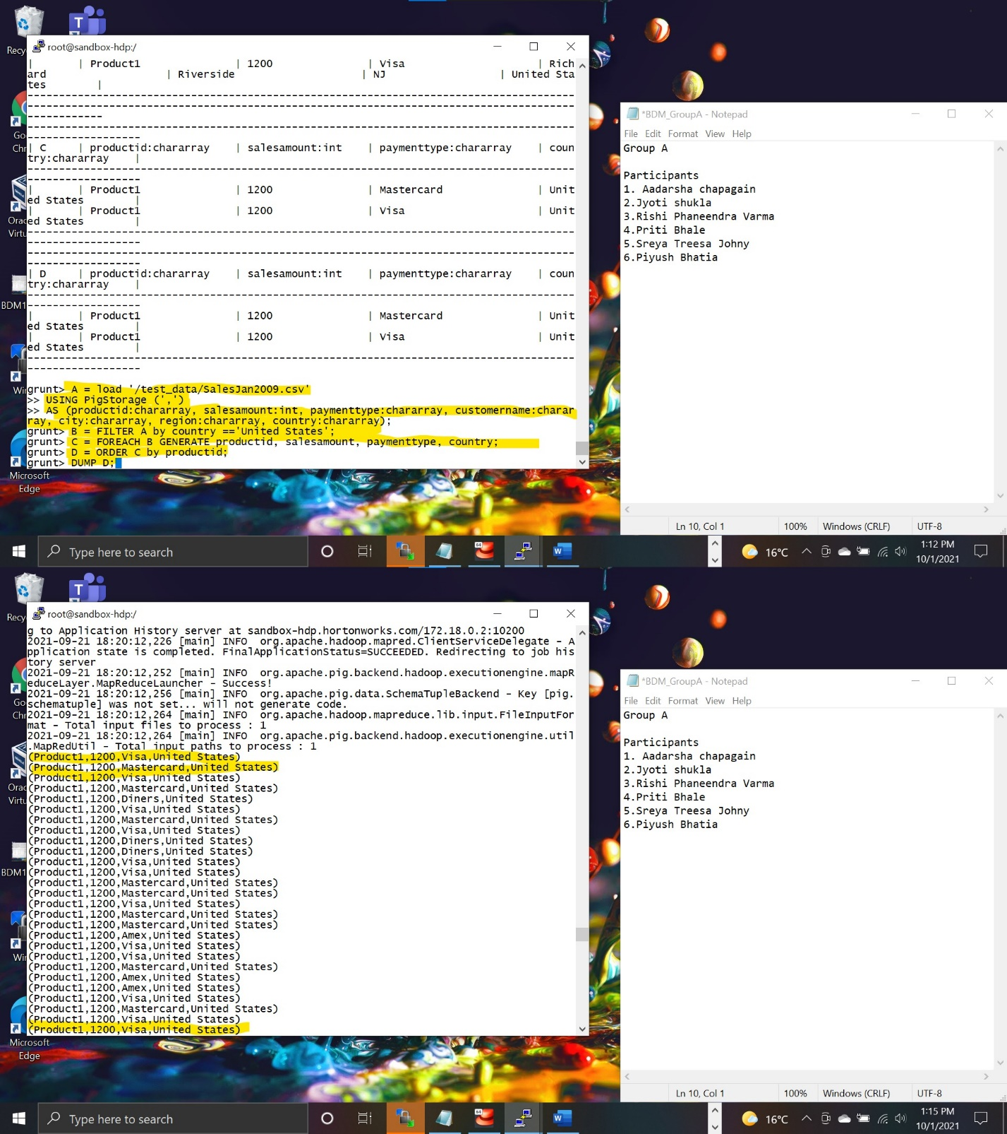

**33.** looping through B and generate productid 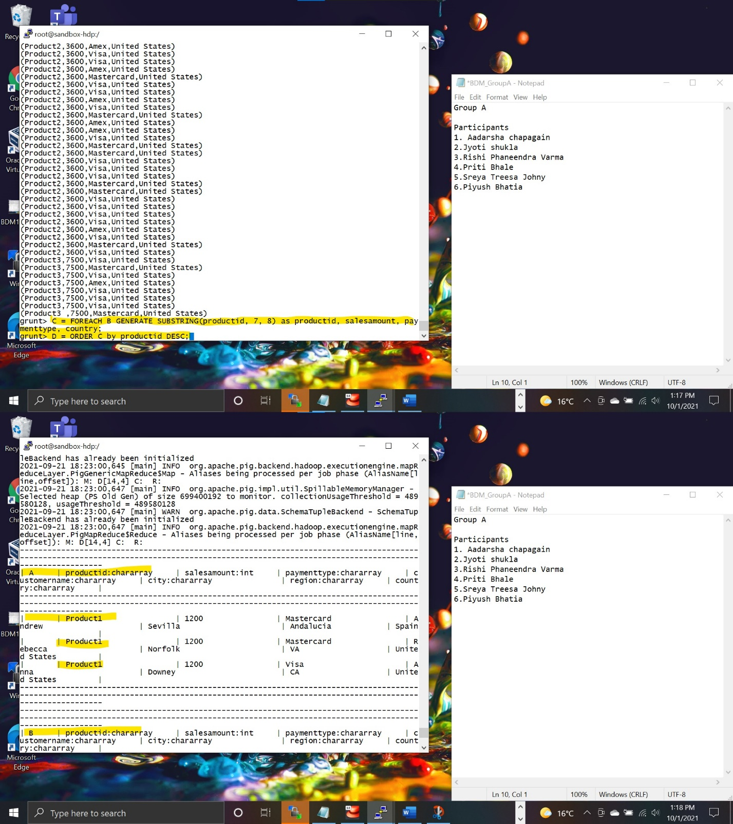

**38.** obtain total_sales after filtering by country and ordering by payment type and store result in hdfs file

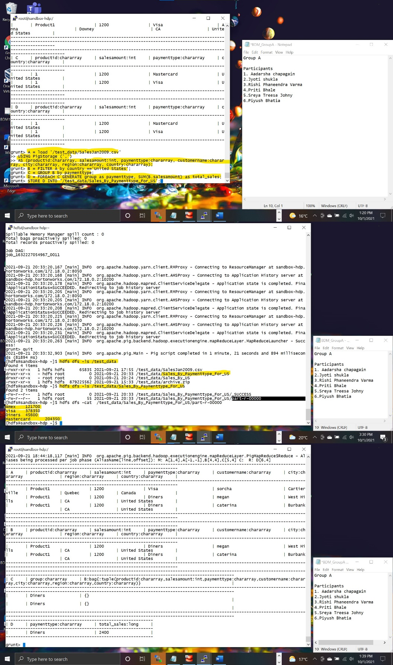

**46.**splitting dataset by country and illustrate b to show lineage

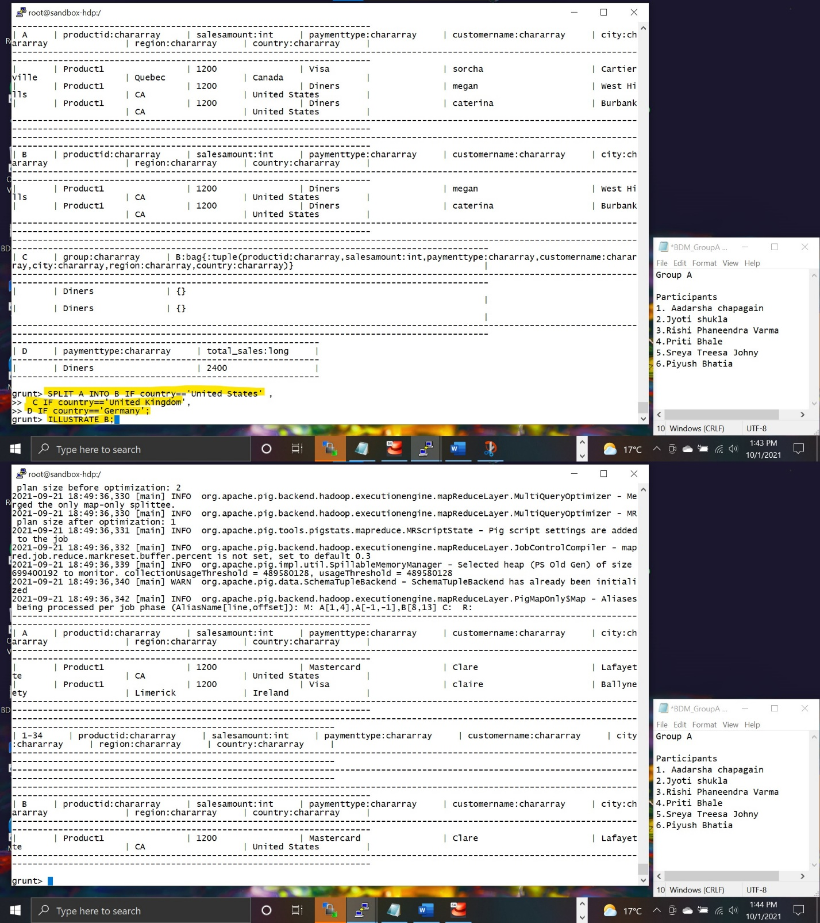

**51.** pig script in a file to automate , change permission to make file executable.